Case Study

IT and Database Consulting Services for GOVGISTICS : Managing 5K New Gov.’t Contracts Daily

Executive Summary

The GovGistics product is a comprehensive single source Government Research and Solicitation Monitoring Tool that delivers RFQ and RFP opportunities from the DoD and other sources to its customers as well as provides access to a complete NSN Database and procurement history which covers DoD, GSA, Emall and more. By using GovGistics, government contractors can more effectively streamline the process of researching, finding and winning DoD contract awards.

GovGistics engaged EndPointConsulting (EPC) to build a robust and scalable backend system to crawl thousands of government documents daily and present the information in an organized manner to GovGistics customers.

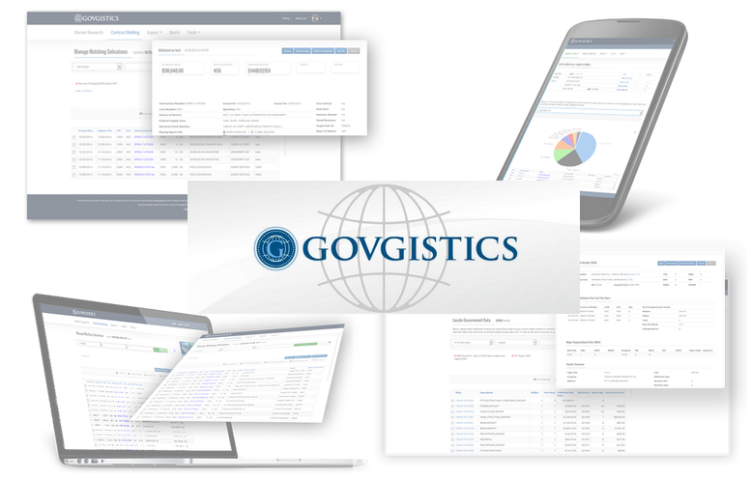

Technologies involved:

* Microsoft SQL Server
* Microsoft .NET Framework
* Custom Spider Development
* HTML5
* ANGULARJS
* NODE.JS
* Web API

Challenges

MarketingG2 (MG2) was a startup organization that was founded by Patrick Glennon. MG2 originally attempted off-shoring development on its own. They were very unhappy with the initial performance when going it alone and engaged the services of EndPointConsulting (EPC). What started off as simple database and administrative services quickly expanded after EPC proved themselves and became MG2’s entire IT and database team.

From there the relationship has grown and the EPC team that now serves MG2 has grown from just 2 people to 9 full time consultants. EPC has been instrumental in building out the MG2 technology stack. Products developed and launched include:

Insert Quote

* Open Intelligence
* Solicitor Concierge
* Mobile Concierge
* Subscriber Concierge
* Touchpoint

How Services Helped

EPC provided the necessary offshore database and IT talent to help MG2 grow cost effectively and maximize value to their clients. EPC has consistently delivered quality products on time and under budget. The services they provided were at a fraction of the cost of onshore local talent.

Results, Return on Investment and Future Plans

Currently EPC has expanded their MG2 partnership by adding a team of QA engineers as well as a web development team. The team now serving MG2’s needs has now grown to 15 people across 2 different offices in Belarus.